URL: https://adityabirlahospital.com/doctors/sexologist-in-pune

Meta Title: Best Sexologists in Pimpri-Chinchwad, Pune | ABMH
Meta Descriptions: Find the best sexologists in Pimpri, Pune at ABMH. Expert care for sexual health issues including ED, low libido, and intimacy concerns. Book an appointment now!
Home / Doctors / Sexologist

Best Sexologists in Pimpri-Chinchwad Pune
A sexologist is a medical professional who specializes in sexual health, offering expert care for individuals or couples facing challenges related to sexual function, sexual health education, and emotional well-being. If you’re looking for a sexologist in Pimpri Chinchwad Pune, our experienced specialists provide discreet and professional care tailored to your needs.

Our Team of Sexologists in Pune
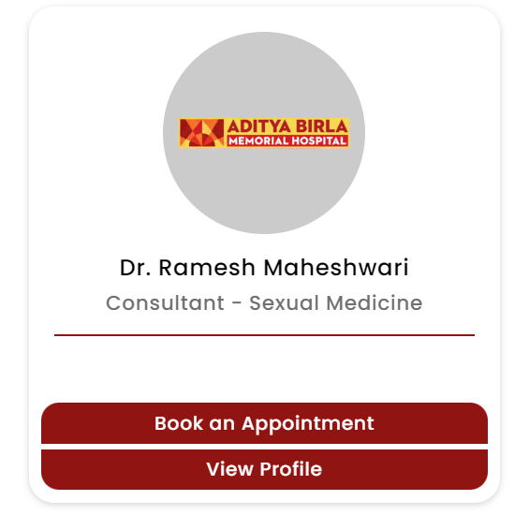
At our sexology hospital in Pimpri Pune, we have some of the best sexologists in Pune, offering compassionate and personalized care for a wide range of sexual health concerns. Whether you’re facing issues like erectile dysfunction, low libido, or emotional difficulties related to intimacy, our top sexologists are here to help.

Our Sexologists Treat Many Conditions, Including:
- Erectile dysfunction (ED)
- Premature ejaculation
- Low libido or decreased sexual desire
- Pain during intercourse (dyspareunia)
- Vaginismus and sexual anxiety
- Performance anxiety and relationship issues
- Hormonal imbalances affecting sexual health
- Sexual dysfunction related to chronic illnesses
- Sexual orientation or identity-related concerns
- Post-menopausal or age-related sexual issues

How Do I Find the Best Sexologist Near Me in Pune?
If you’re searching for a sexologist near me or the best sexologist doctor in Pune, our hospital offers expert treatment in a comfortable and confidential environment. We understand that addressing sexual health issues can be sensitive, and we are dedicated to providing a compassionate approach to help you navigate these challenges.
Our hospital is easily accessible from nearby areas, so finding a sexologist doctor in Pune who meets your needs is more convenient.
Nearby Locations:
Hinjewadi, Wakad, Baner, Aundh, Pimple Saudagar, Bhosari, Chinchwad Gaon, Tathawade, Nigdi, PCMC, Pimpri, Ravet, Moshi, and Chakan


